**PGE 392K – Dr. Balhoff’s Numerical Reservoir Simulation Class**

**CMG TUTORIAL FOR PROJECT 2: MULTIPHASE FLOW**

By: Jenny Ryu

1. Click Builder
2. Click White Page Button under File Tab

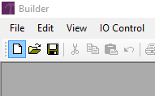

1. Builder – Reservoir Simulator Settings will pop up
2. Select IMEX for simulator, Field for working units, and single Porosity for Porosity

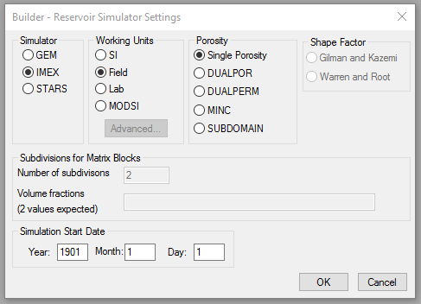

1. Click Ok 2x

**RESERVOIR**

1. Click the triangle to the right of the Reservoir tab in the Model Tree View

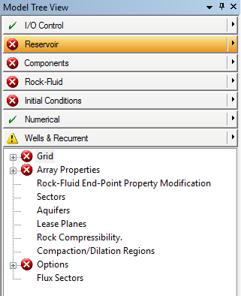

1. Click Create grid
2. Click Cartesian
3. Type in number of grid blocks in I, J, and K direction

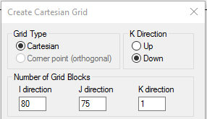

1. Type the width of each block using (# of gridblock*size) notation

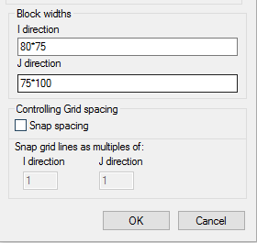

1. Click ok
2. Click Array Properties in Model Tree View

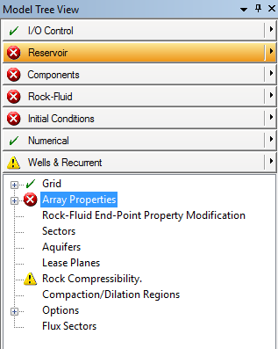

1. Set Grid Top to 1000 feet for Layer 1 (left column). We will later edit the text file to add heterogeneity.
2. Set Grid Thickness to 50 feet for whole grids (left column)
3. Set porosity to any value between 0 and 1 for whole grids. We will later edit the text file to add heterogeneity.

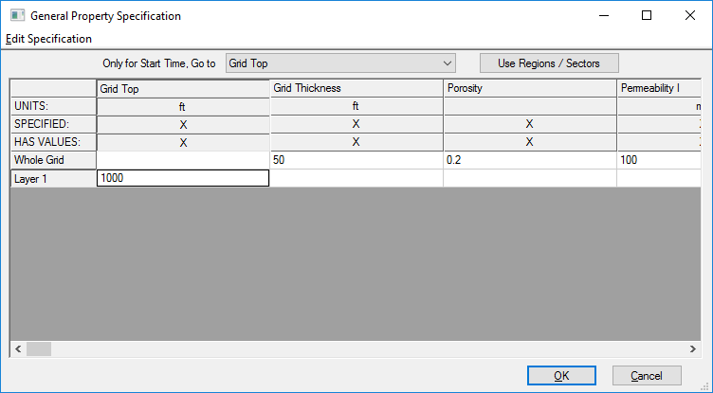

1. Set permeability I to any value for whole grids. Again, we will later edit text file to add heterogeneity
2. Set permeability J to Equals I*0.15 by right clicking on the whole grids box of permeability J and clicking Edit Specifications

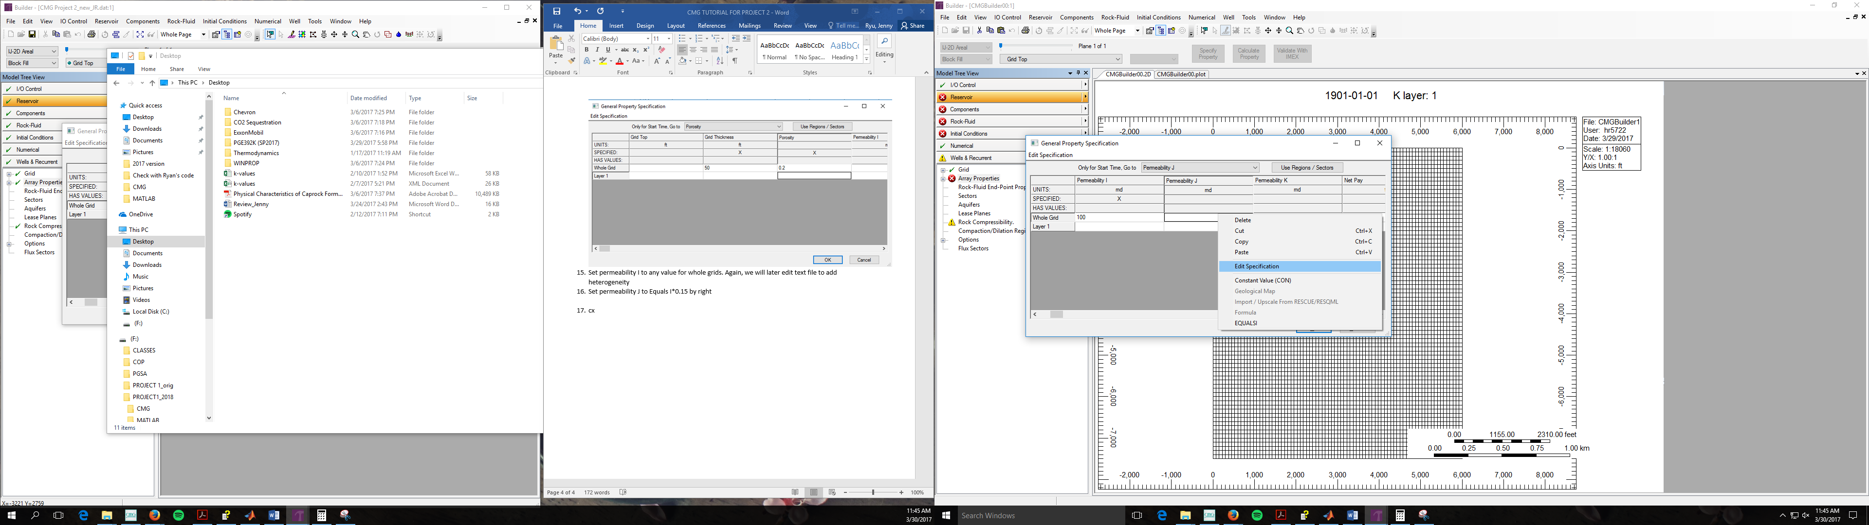

1. Use the drop down menu next to Equals I and select * and type in the ky/kx value

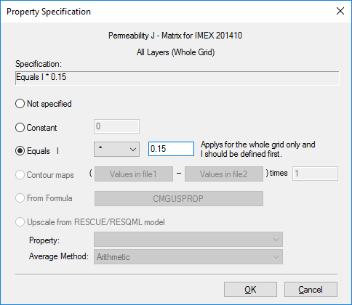

1. Click Ok
2. Set permeability K to Equals I (equal) by right clicking on the whole grids box of permeability K and clicking Edit Specifications

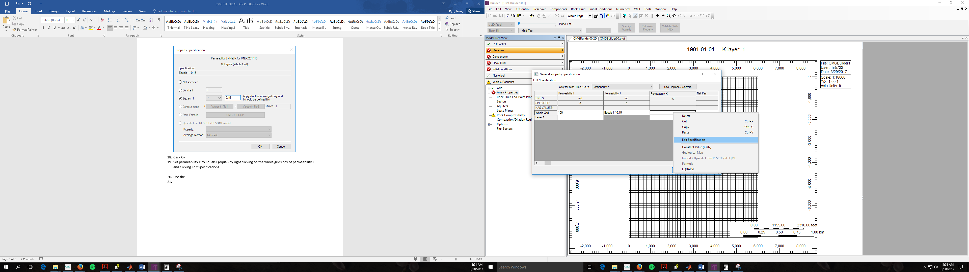

1. Use the drop down menu next to Equals I and select equal
2. Click Ok
3. Permeability I, J, K should look like below

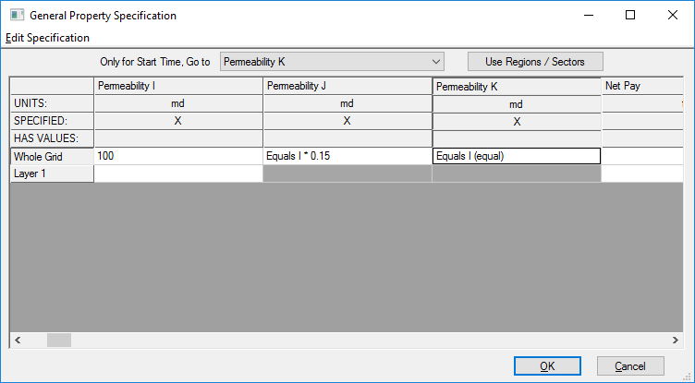

1. Set Null Blocks to Porosity <=0 by right clicking the whole grids box of NULL Blocks and click edit specification

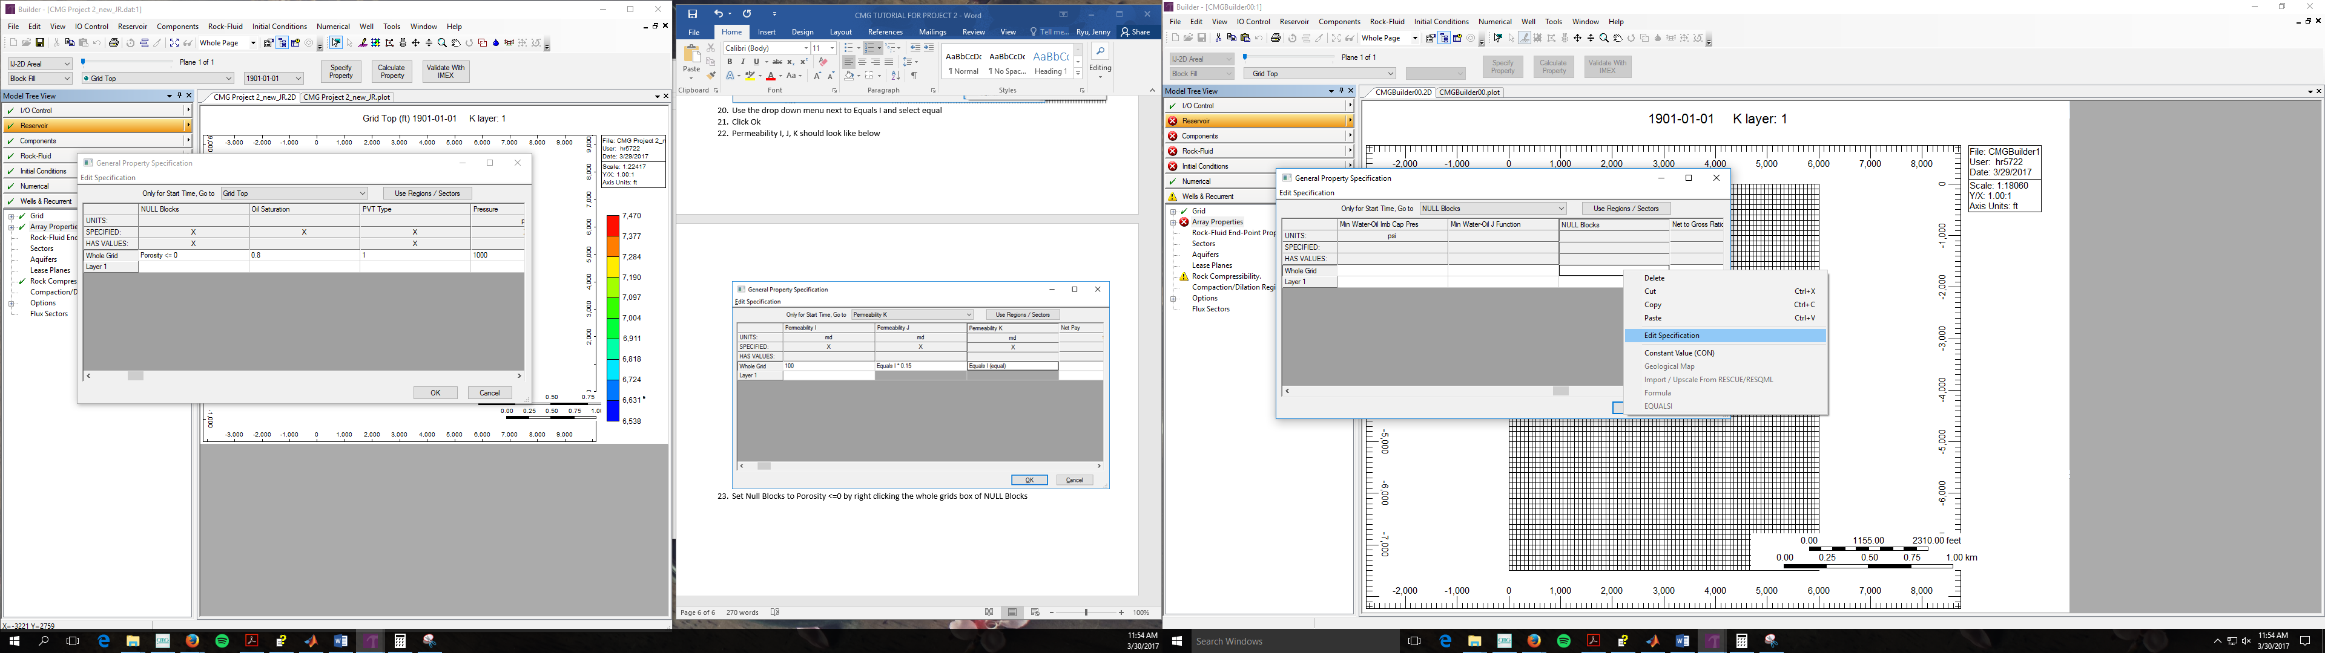

1. Select Set blocks to NULL where and check box next to Porosity is less than or equal to 0

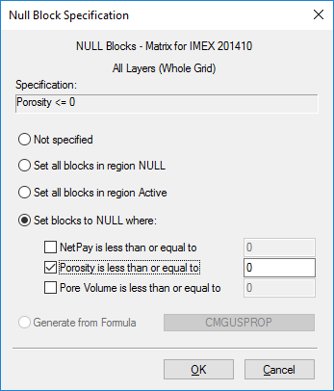

1. Click ok
2. Click ok of the General Properties Specification
3. Click ok again
4. Click Rock Compressibility in Model Tree View

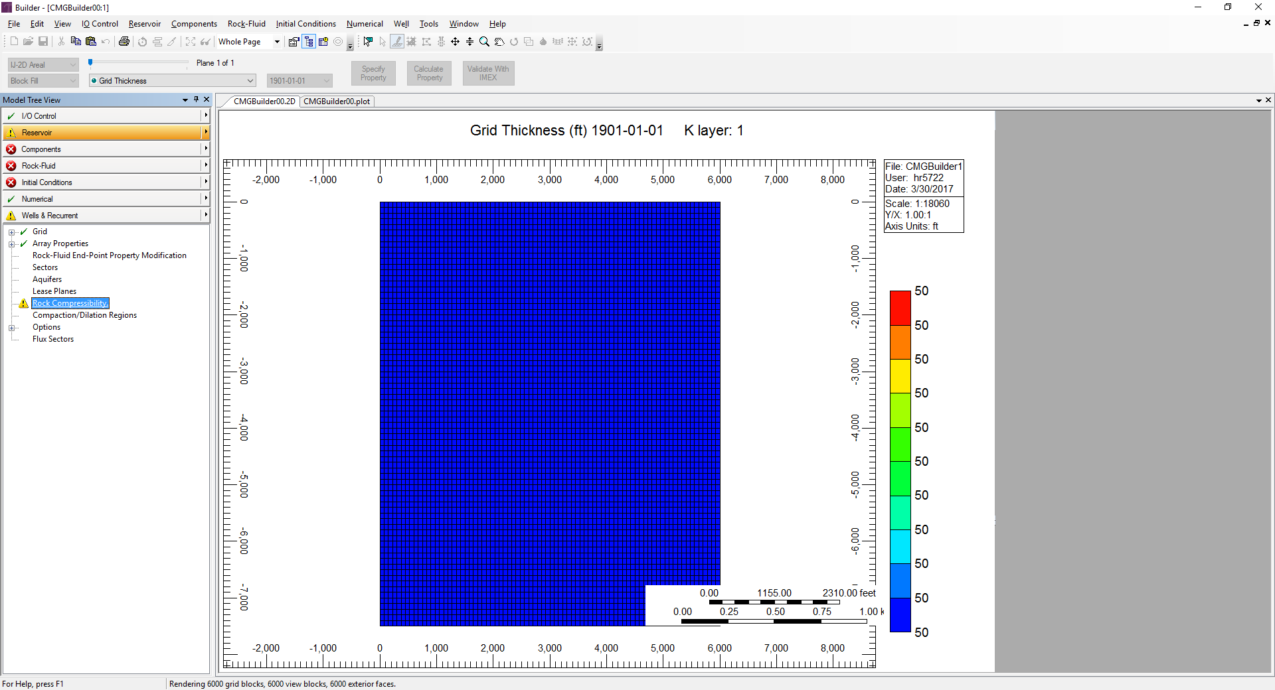

1. Type compressibility of formation as 1 e-6 1/psi

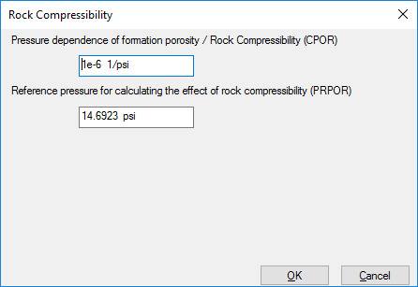

**COMPONENTS**

1. Click Components in Model Tree View

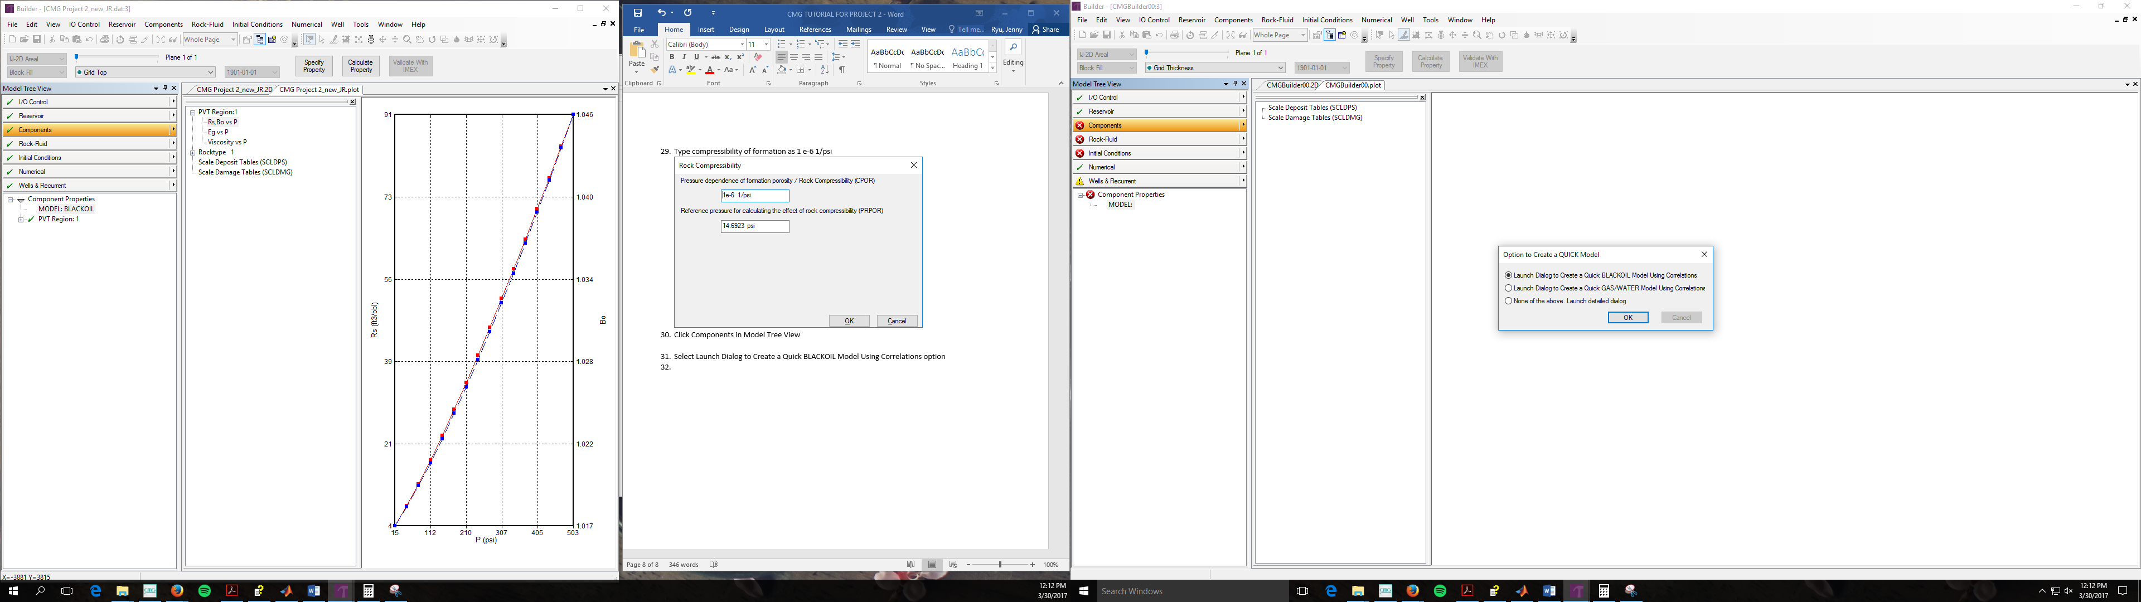

1. Select Launch Dialog to Create a Quick BLACKOIL Model Using Correlations option

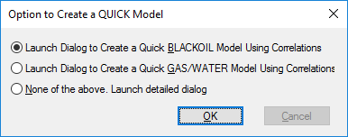

1. Click Ok
2. Set reservoir temperature to 100 F
3. Set Generate data upto max. pressure of to 5300 psi
4. Set Bubble point pressure calculation to Value provided (dropdown menu) and to a value of 502.505 psi
5. Set Oil density at STC to Stock tank oil density (dropdown menu) and to a value of 53 lb/ft
6. Set Gas density at STC to Gas gravity (dropdown menu) and to a value of 0.6 (This is equivalent to selecting gas density and assigning a value of 0.0458171 lb/ft3)
7. Set Pressure dependence of water viscosity to 0 cp/psi
8. Your Quick Blackoil Model should look like below

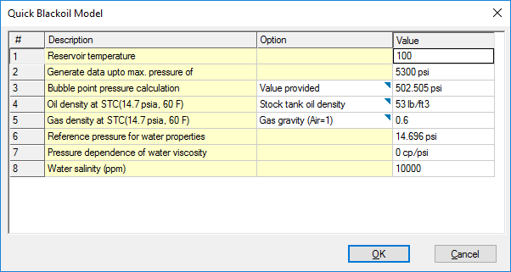

1. Click ok
2. Click PVT Region: 1 in Model Tree View

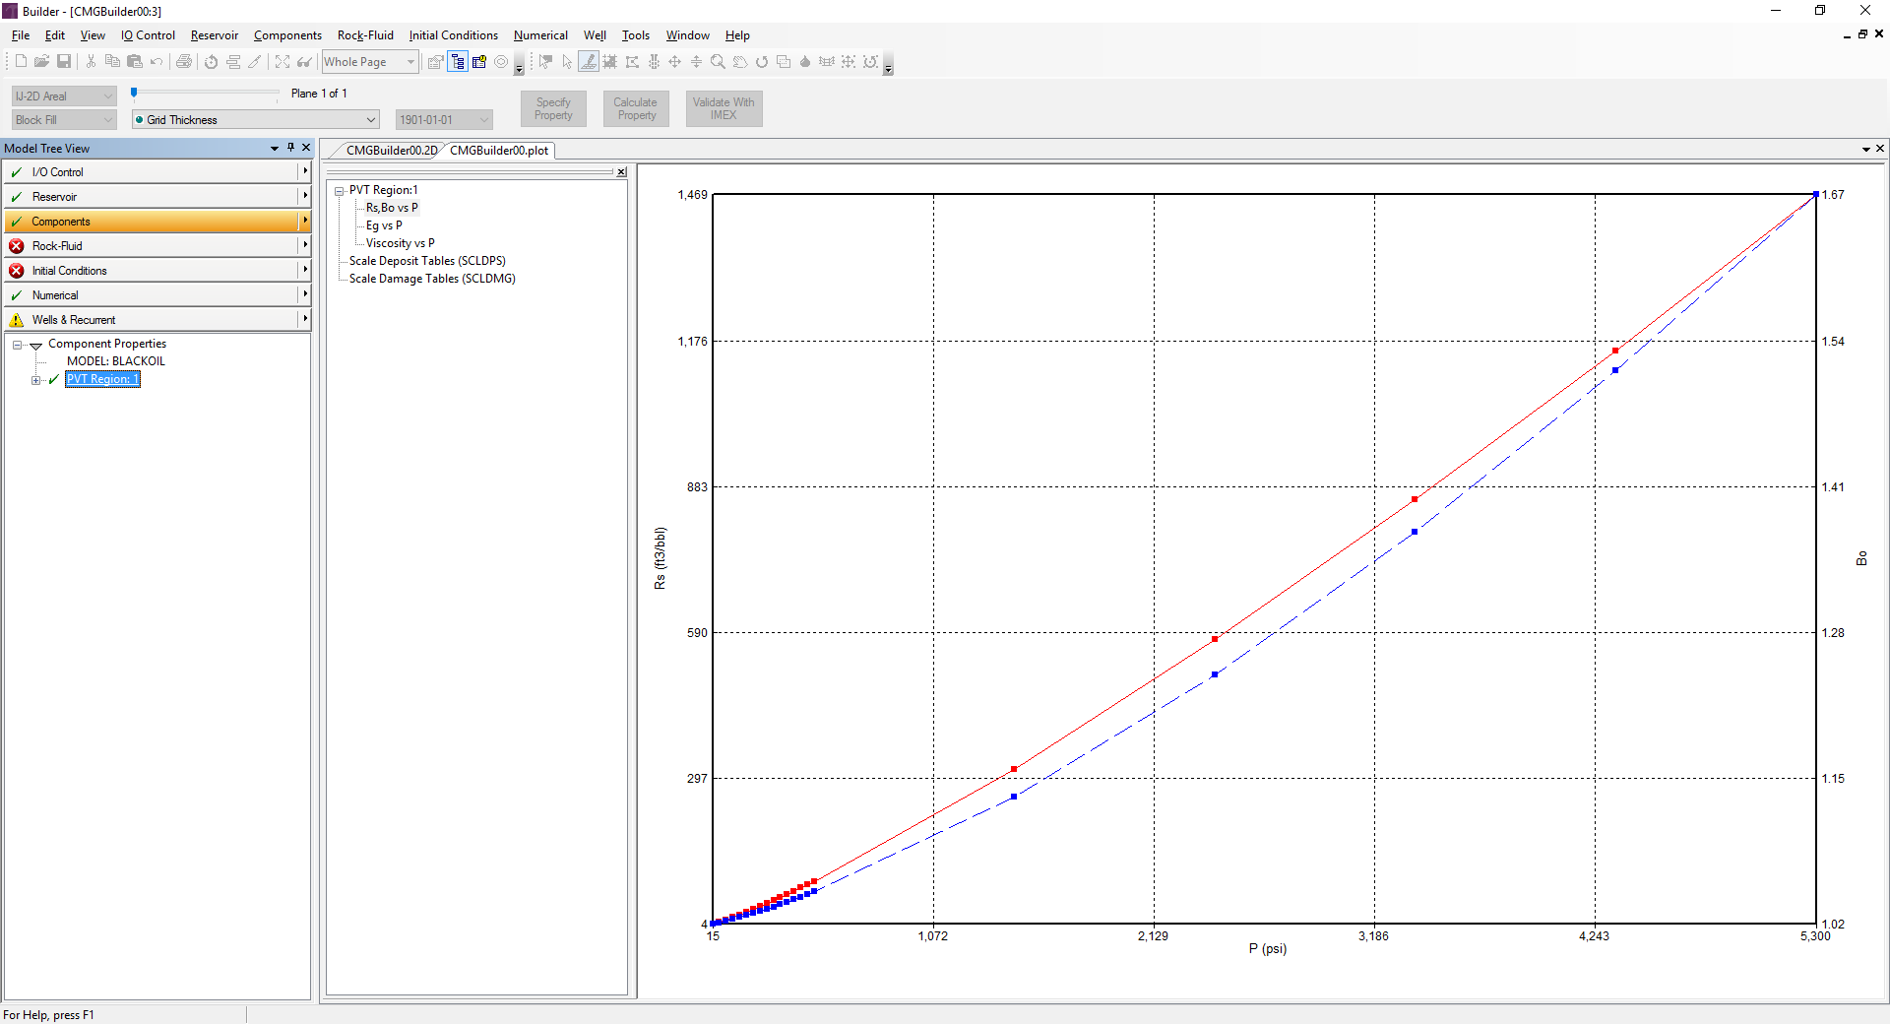

1. Under the General Tab on the top left hand corner, set Reservoir Temperature again to 100F
2. Change water density to 62.4 lb/ft3
3. Set Undersaturated Co to 3e-6 1/psi
4. Set Vo pressure dependence to 0.0001 cp/psi
5. Change Formation Volume Factor to 1.012298811
6. Change compressibility to 2.87e-006 1/psi
7. Change Reference pressure for FVF to 4500 psi
8. Change water viscosity to 0.383 cp
9. Imex PVT Regions should look like below

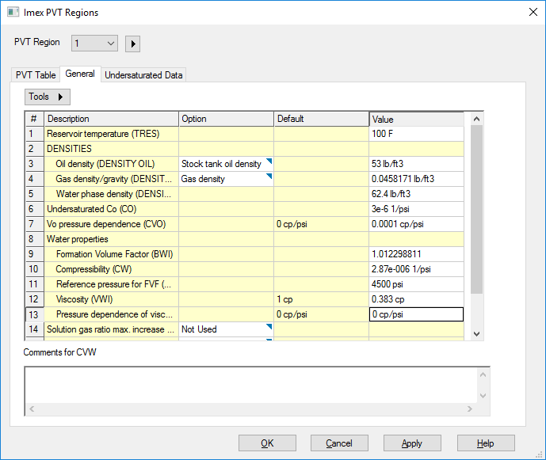

1. Click Apply
2. Move to the PVT Table tab on the top left hand corner
3. Deselect Include Oil Compressibility in PVT Table

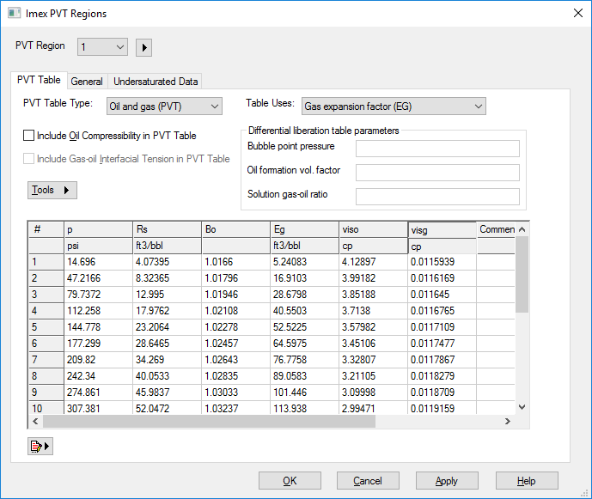

1. Click Apply
2. Click Ok

**ROCK-FLUIDS**

1. Click Rock-Fluids in Model Tree View

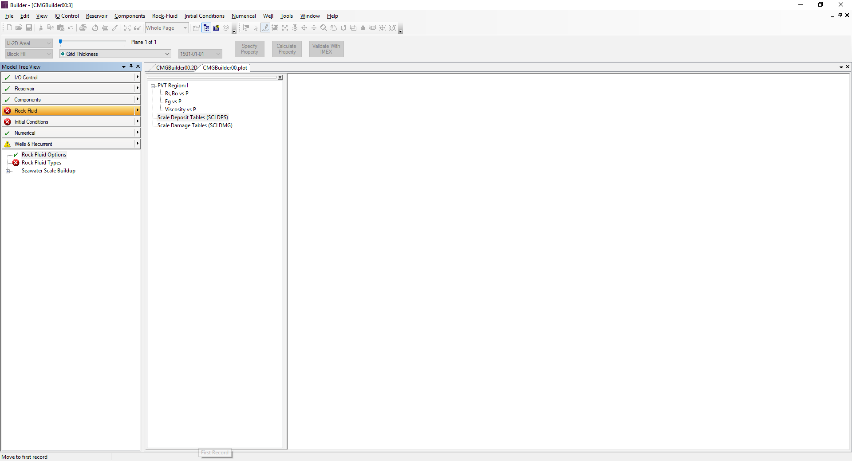

1. Click Rock Fluid Types in Model Tree View

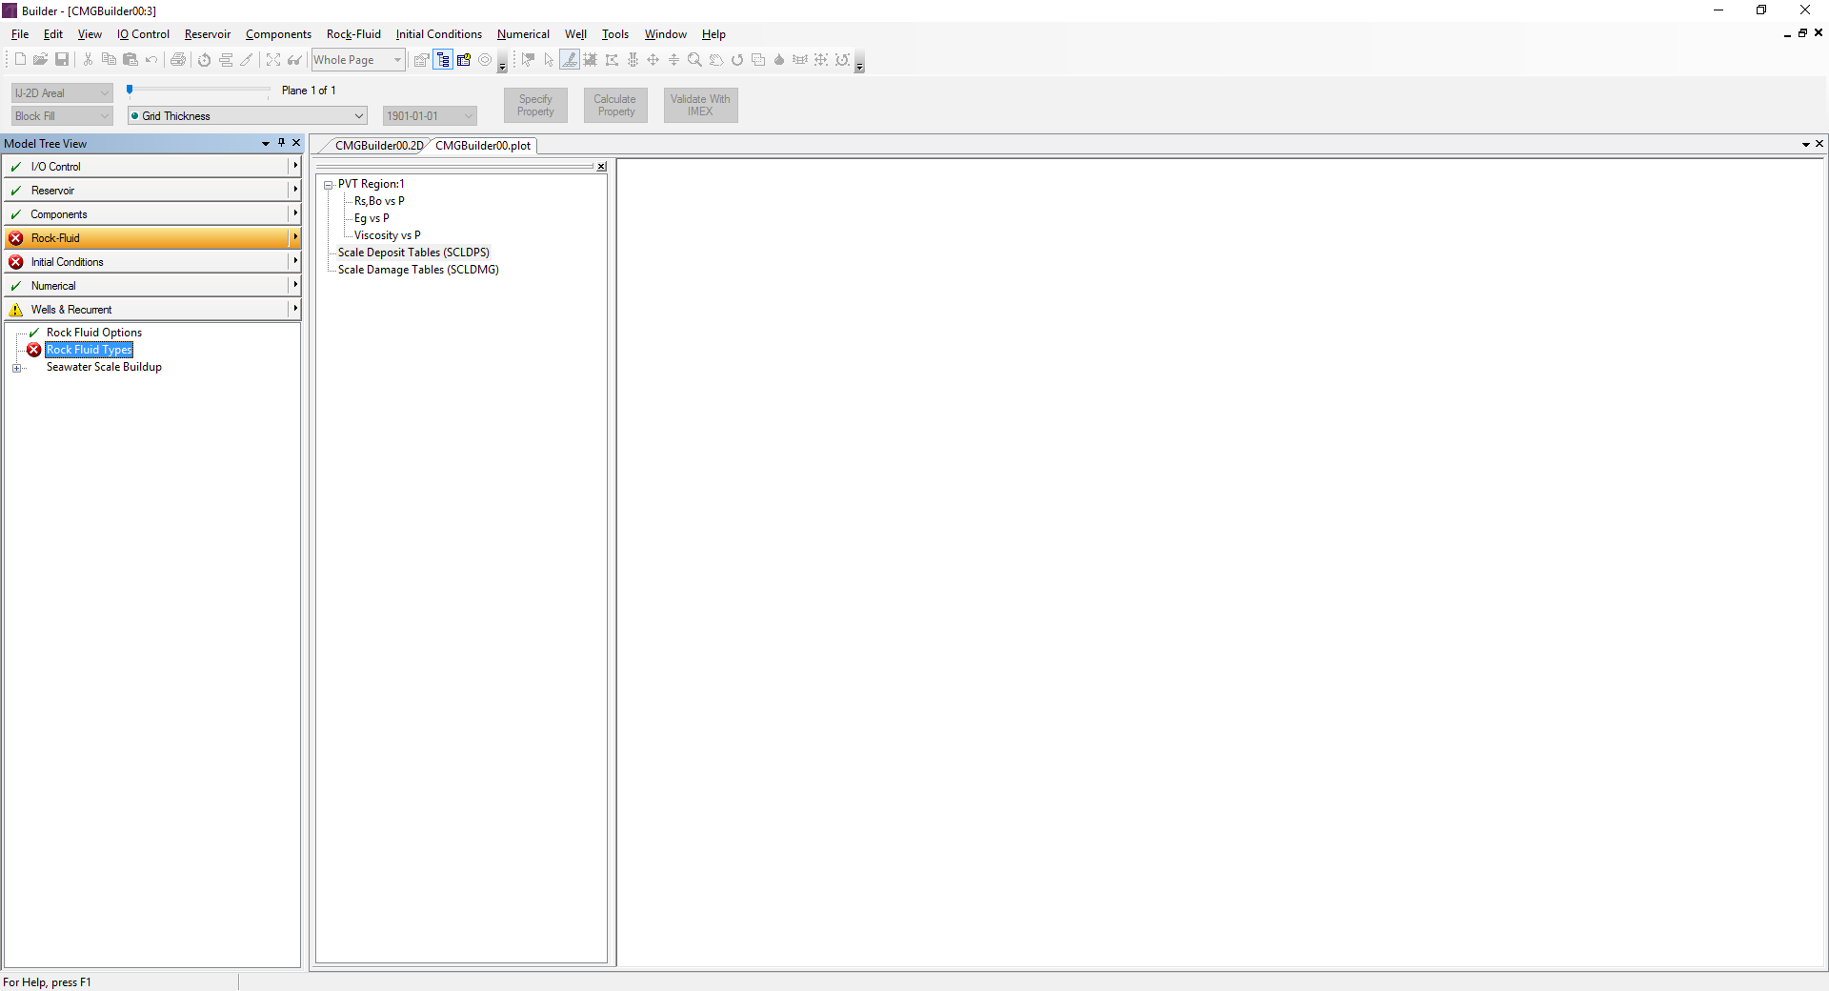

1. Click on the triangle pointing to the right next to Rock Type and select New Rock Type

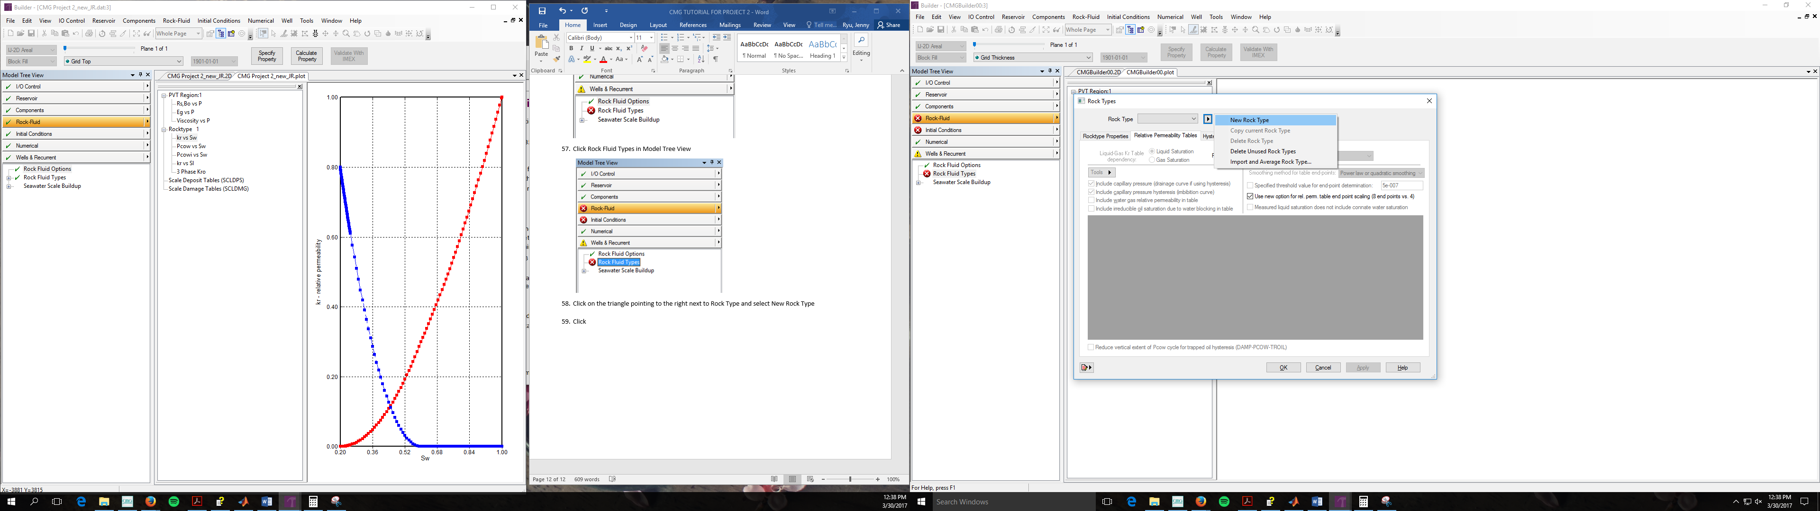

1. Select Tools
2. Choose generate table using correlation 🡪 this will populate the water-oil and liquid gas table
3. Input values given in the problem statement

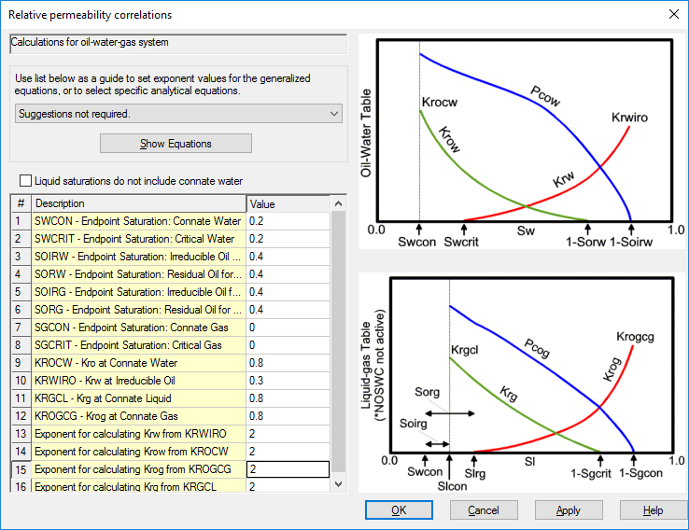

1. Copy and paste Sw, krw, krow, Pcow, and Pcowi from excel sheet

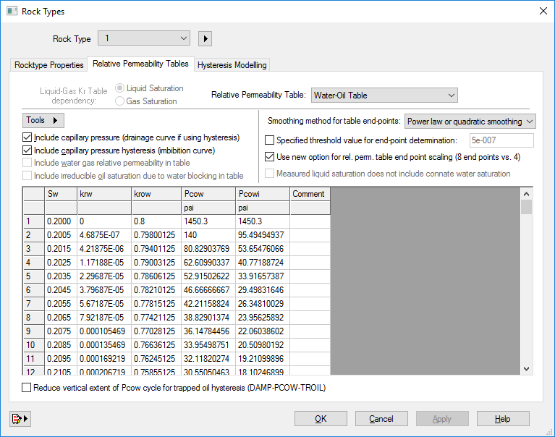

1. Click Apply
2. Click on Hysteresis Modelling Tab
3. Check 1st option (Model hysteresis effect in O-W capillary pressure or J function).
4. Set transition between imbibition and drainage curve to 0.1

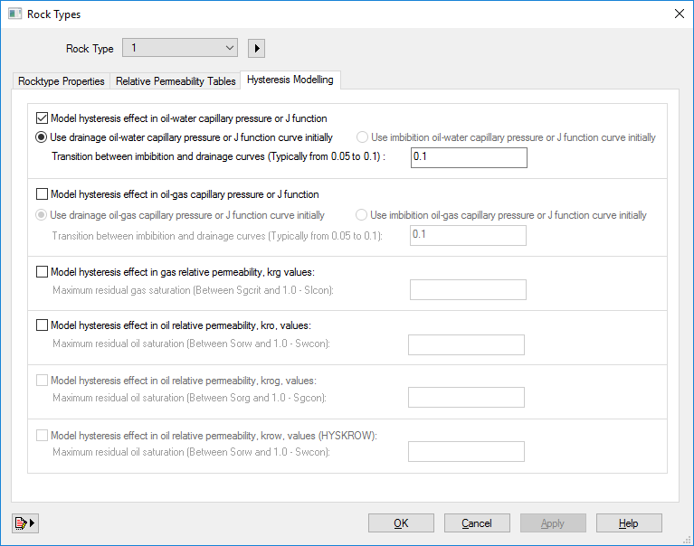

1. Click Apply
2. Click Ok

**INITIAL CONDITIONS**

1. Click Initial Conditions in Model Tree View

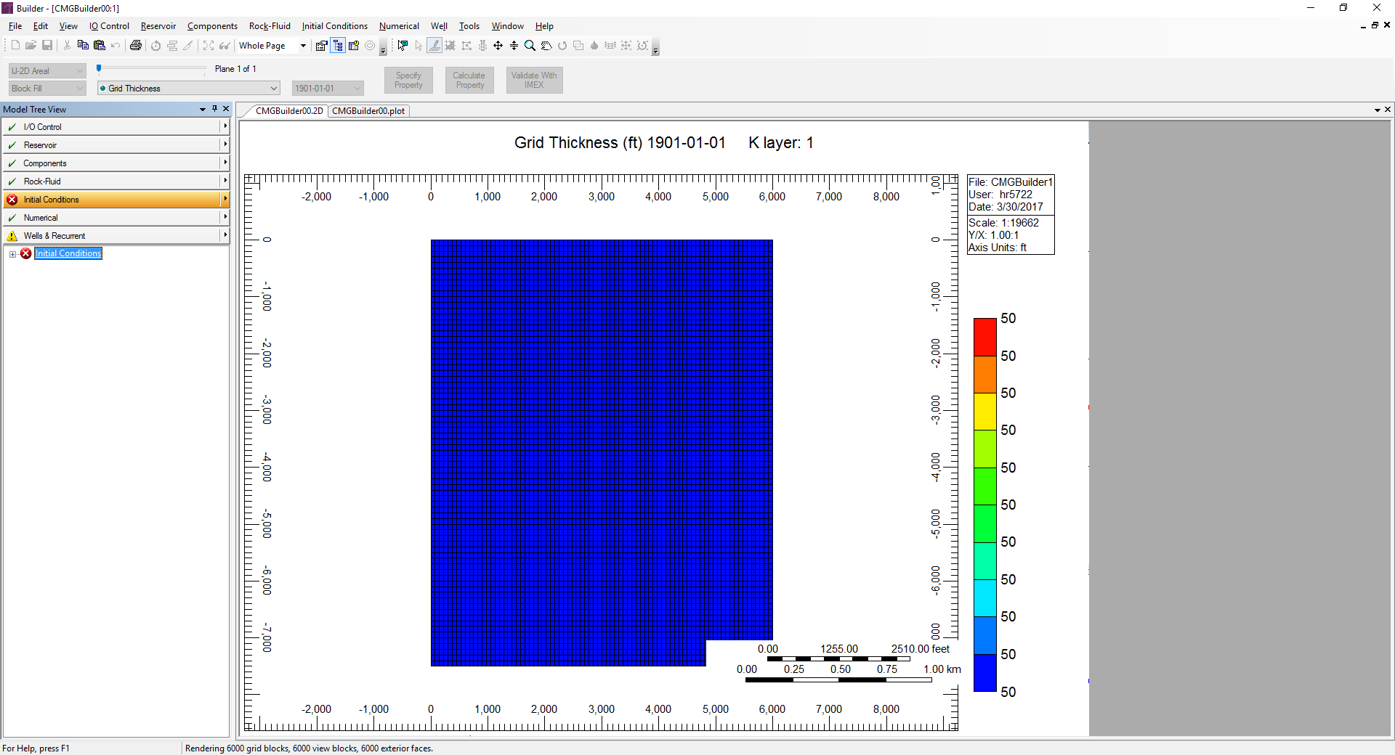

1. Click the Advanced button

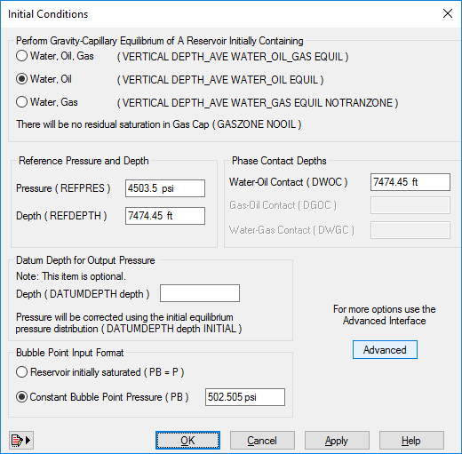

1. Under Calculation Methods (top left corner), select Block Saturation at each grid block same as saturation prevailing at the block center
2. Select Water, Oil
3. Click Apply
4. Your Calculation Methods tab should look like below

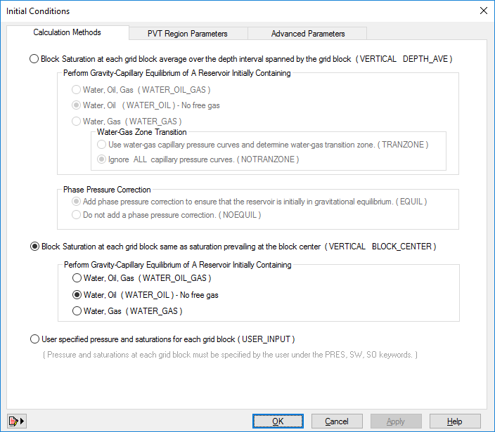

1. Click on the PVT Region Parameters
2. Set Reference Pressure to 4503.5 psi (this value is water pressure at WOC plus the entry pressure = 4500+3.5=4503.5)
3. Set Reference Depth to WOC = 7474.45 ft
4. Set Water-Oil Contact to 7474.45 ft
5. Select Constant Bubble Point pressure for Bubble Point input format
6. Set Constant Bubble Point to 502.505 psi
7. Your PVT Region Parameters should look like below

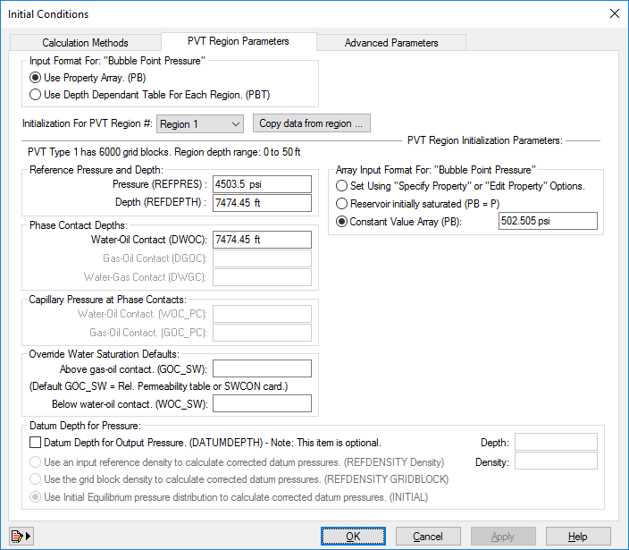

1. Click Apply
2. Click Ok

**NUMERICAL CONTROLS**

1. Click Numerical Controls in Model Tree View

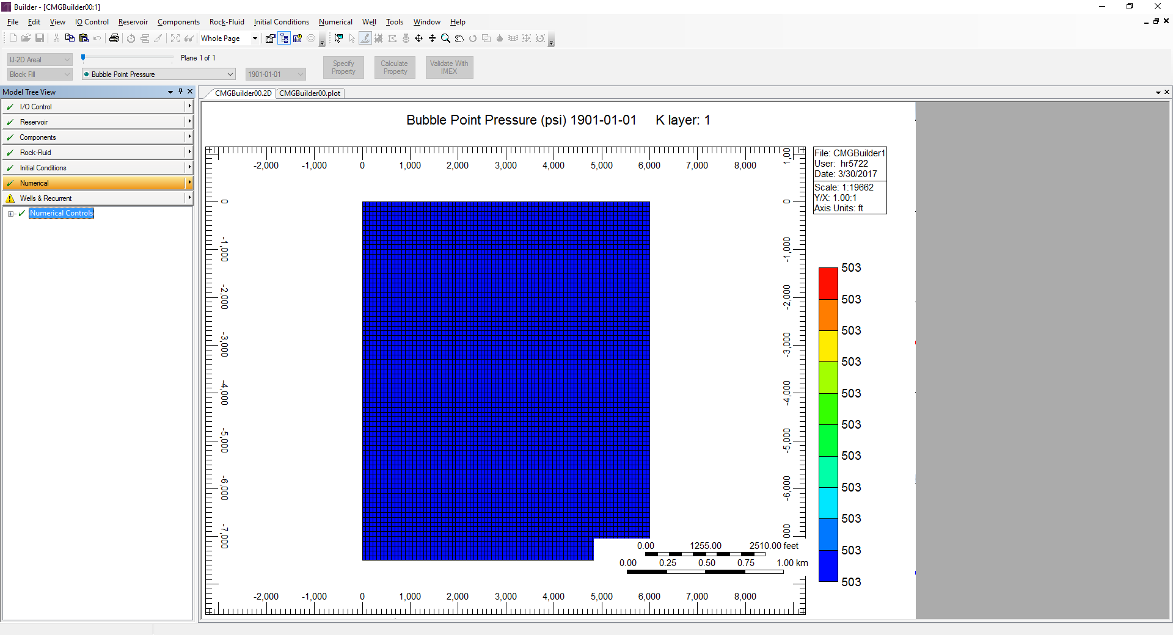

1. Set DTMAX to 1 day
2. Set DTWELL to 1 day
3. Set DTMIN to 0.999999 day (please assign DTWELL before assigning DTMIN)
4. Your Numerical should look like below

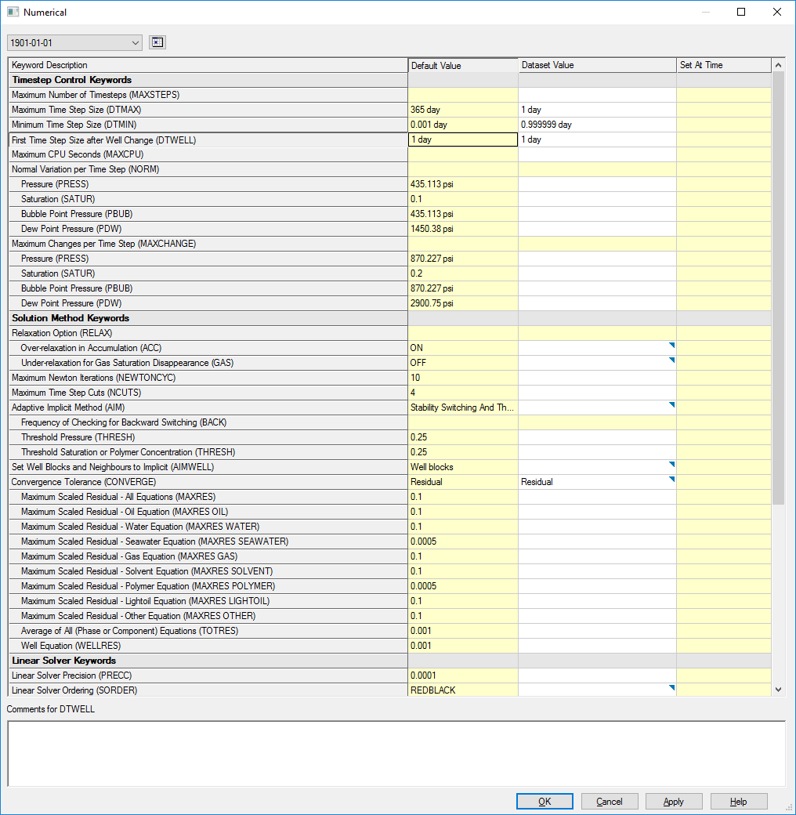

1. Click apply
2. Click ok

**WELLS**

1. Click Wells under Wells & Recurrent

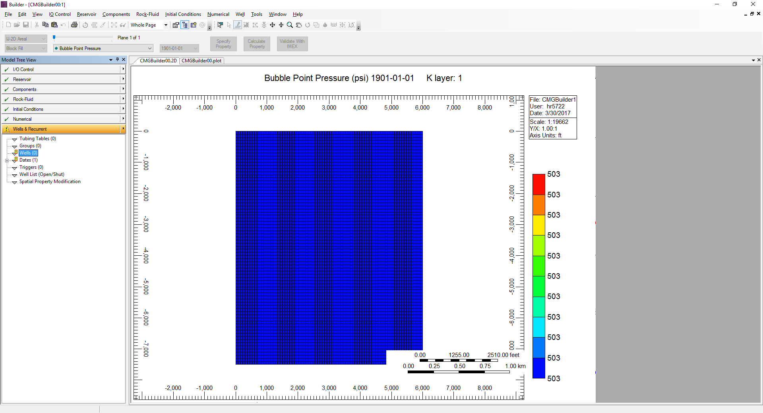

1. Select Type: Producer

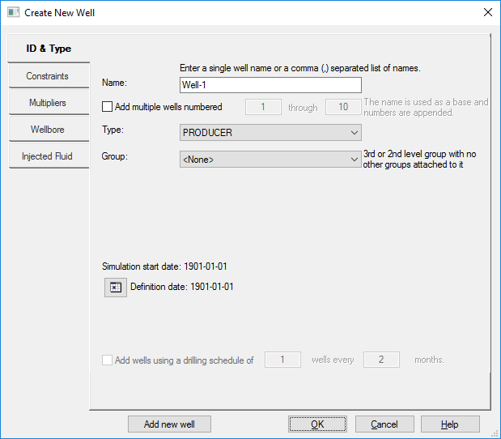

1. Click on Constraints on the side bar
2. Check Constraint definition
3. For Constraints, select OPERATE
4. For Parameter, select STL
5. For Value, type in the value to 120 bbl/day

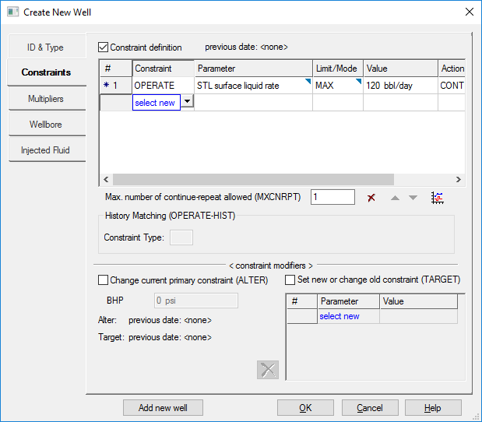

1. Add another constraint by using the dropdown menu named select new under constraint
2. Select operate
3. For Parameter, select BHP
4. For Value, set to 502.505 (bubble point) because we want to keep P above BP
5. Click Add new well on the bottom left hand corner

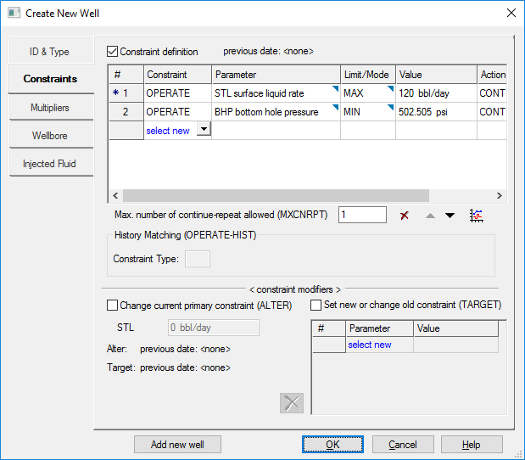

1. Repeat step 2~12 for all 6 wells
2. Click on one of the wells in Model Tree view

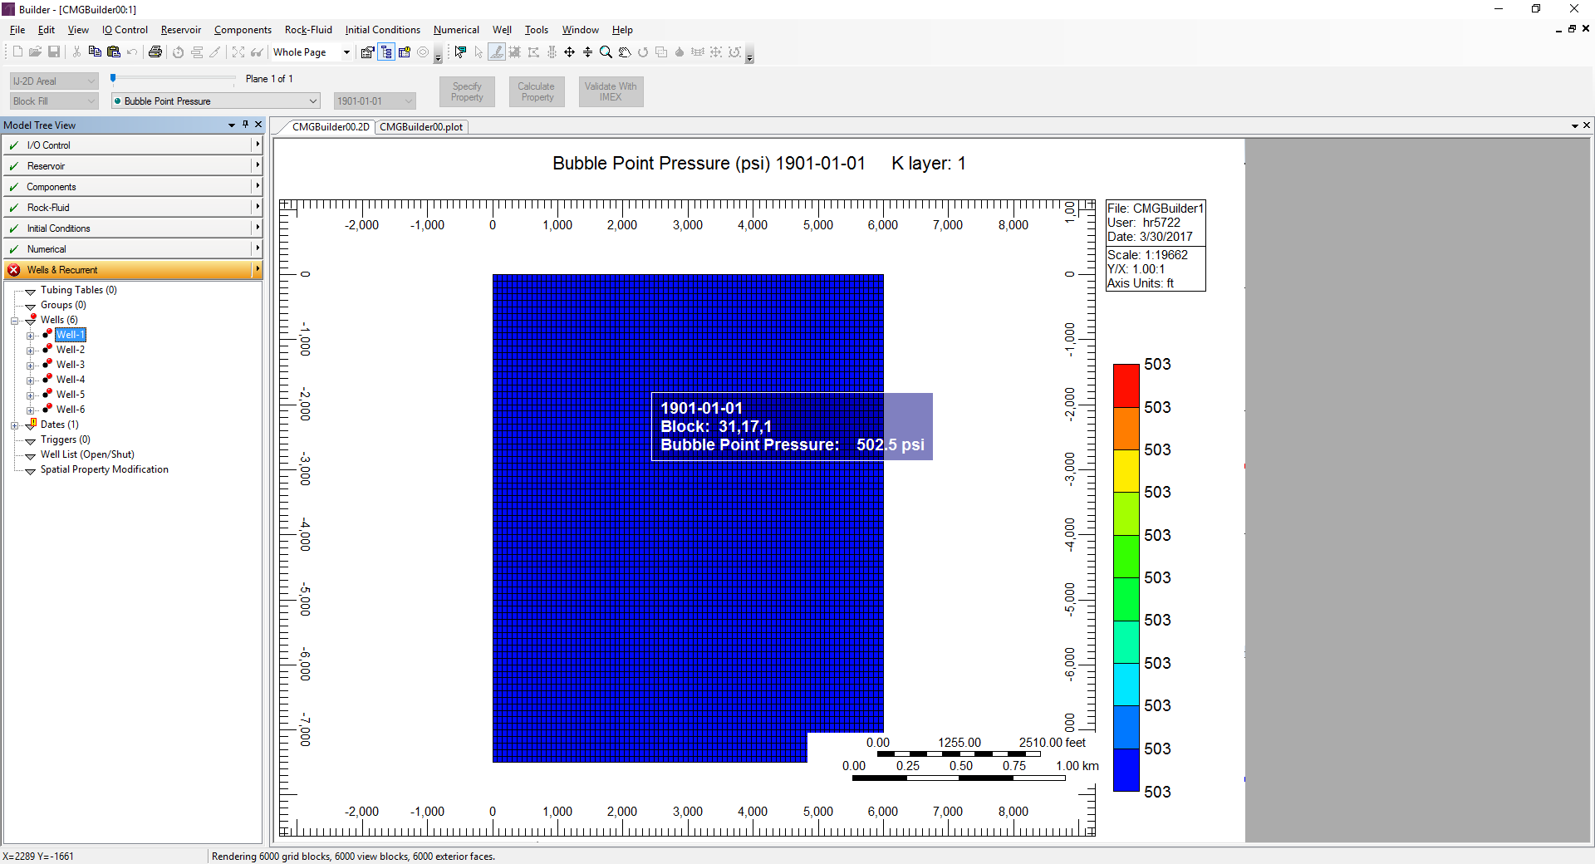

1. Click on the calendar icon on the top next to the date

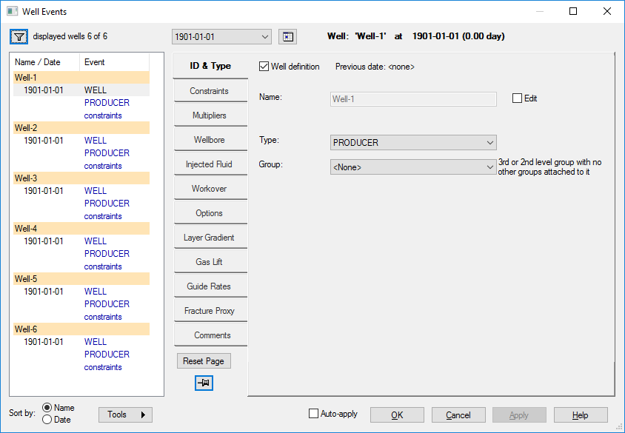

1. Change Days since simulation start and enter **500** days and click on an empty box in the calendar🡪 the calendar will change to determine **500** days from simulation start

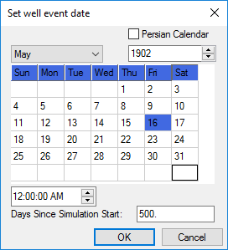

1. Click Ok
2. Click Constraints on the side
3. Select the Constraint Definition box
4. Select STL and press the red X button

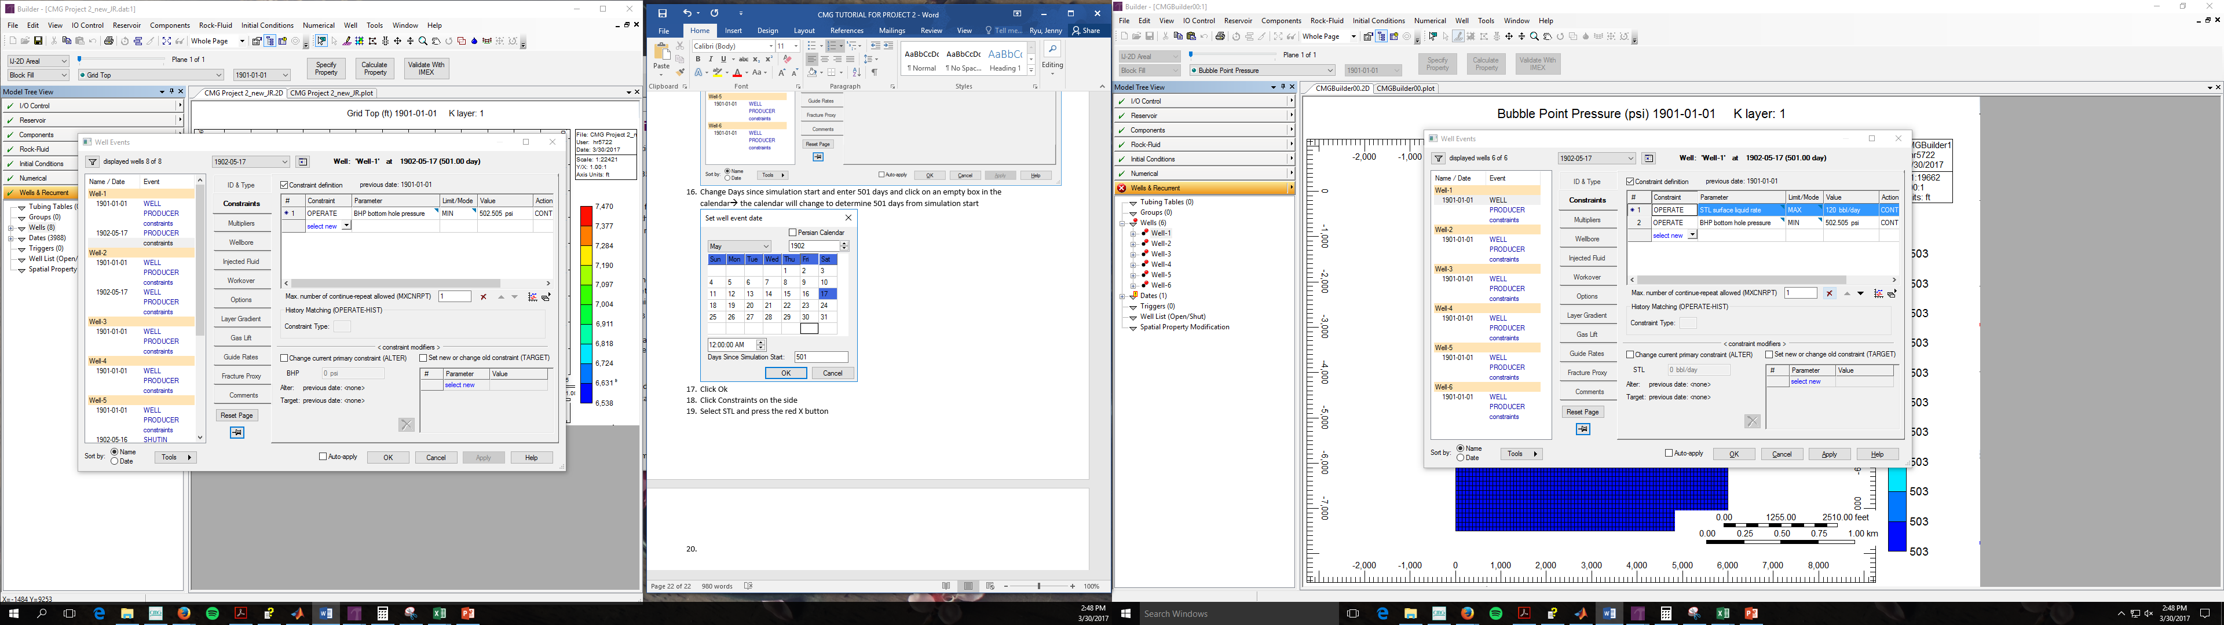

1. Click Apply
2. Repeat step 15~21 for well-2
3. For well 5 and 6, they are turned into injector, so we need to put an injector well in the same location as that of the producer and shut in the producer
4. Repeat step 16
5. Go to Options in the side bar
6. Check the status box
7. And select SHUTIN from the dropdown menu

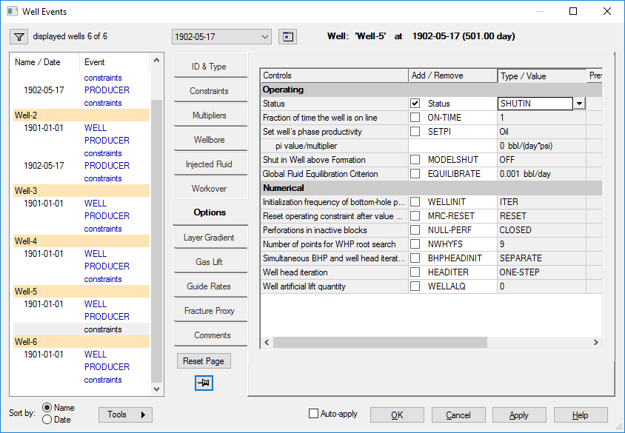

1. Click Apply
2. Repeat step 24~28 for well 6
3. Add injector well by right clicking on wells in the Model Tree View then click new

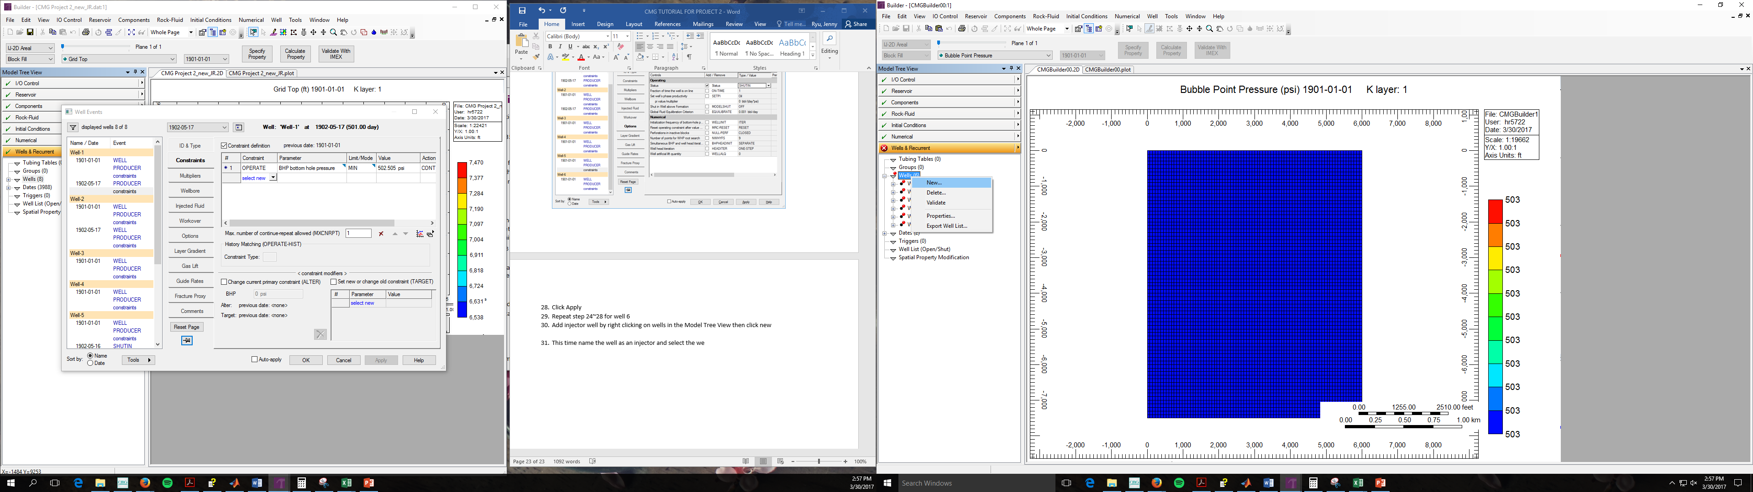

1. Name the well as an injector
2. Select INJECTOR MOBWEIGHT for type

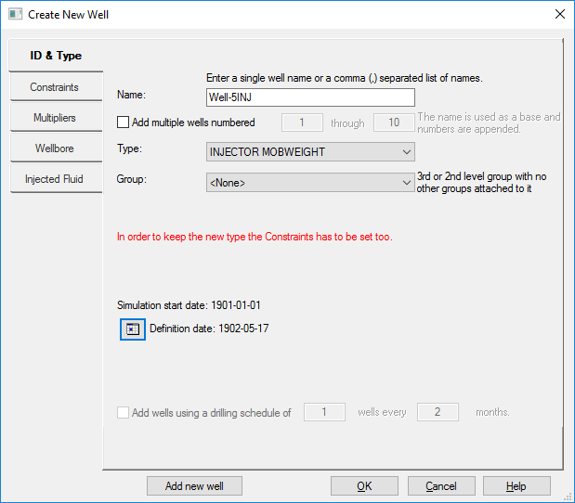

1. Click on the calendar icon and select definition date as **501** days since simulation start (pop-up screen should be very similar to step 16)

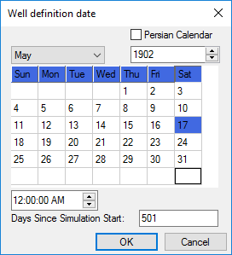

1. Click ok
2. Click on the constraints side bar
3. Check Constraint definition box
4. Select OPERATE for constraint
5. Select STW
6. Set Value as 500 BPD
7. Repeat step 30~39 for Well-6
8. Click on the + sign next to the 1st well and click on 1901-01-01 PERF

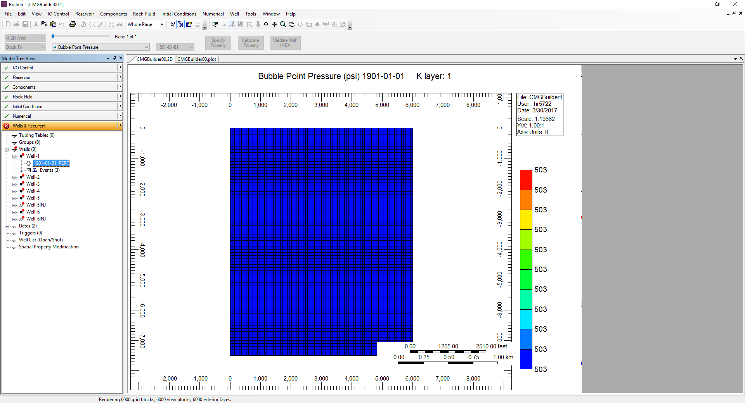

1. Click on the Perforations tab
2. Click on the icon to the left of the # in the chart
3. Below screen will show up

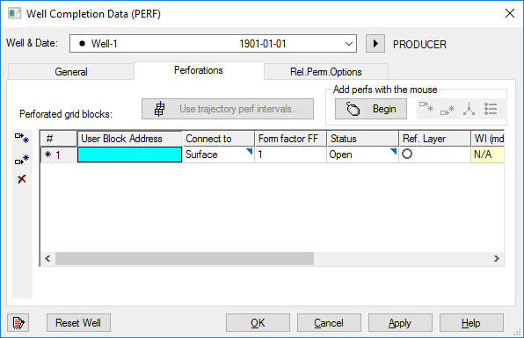

1. Enter block values that correspond to the block perforation in the mint colored box
2. Repeat for all 6 wells and 2 injectors
3. Click on Dates on the Model Tree View

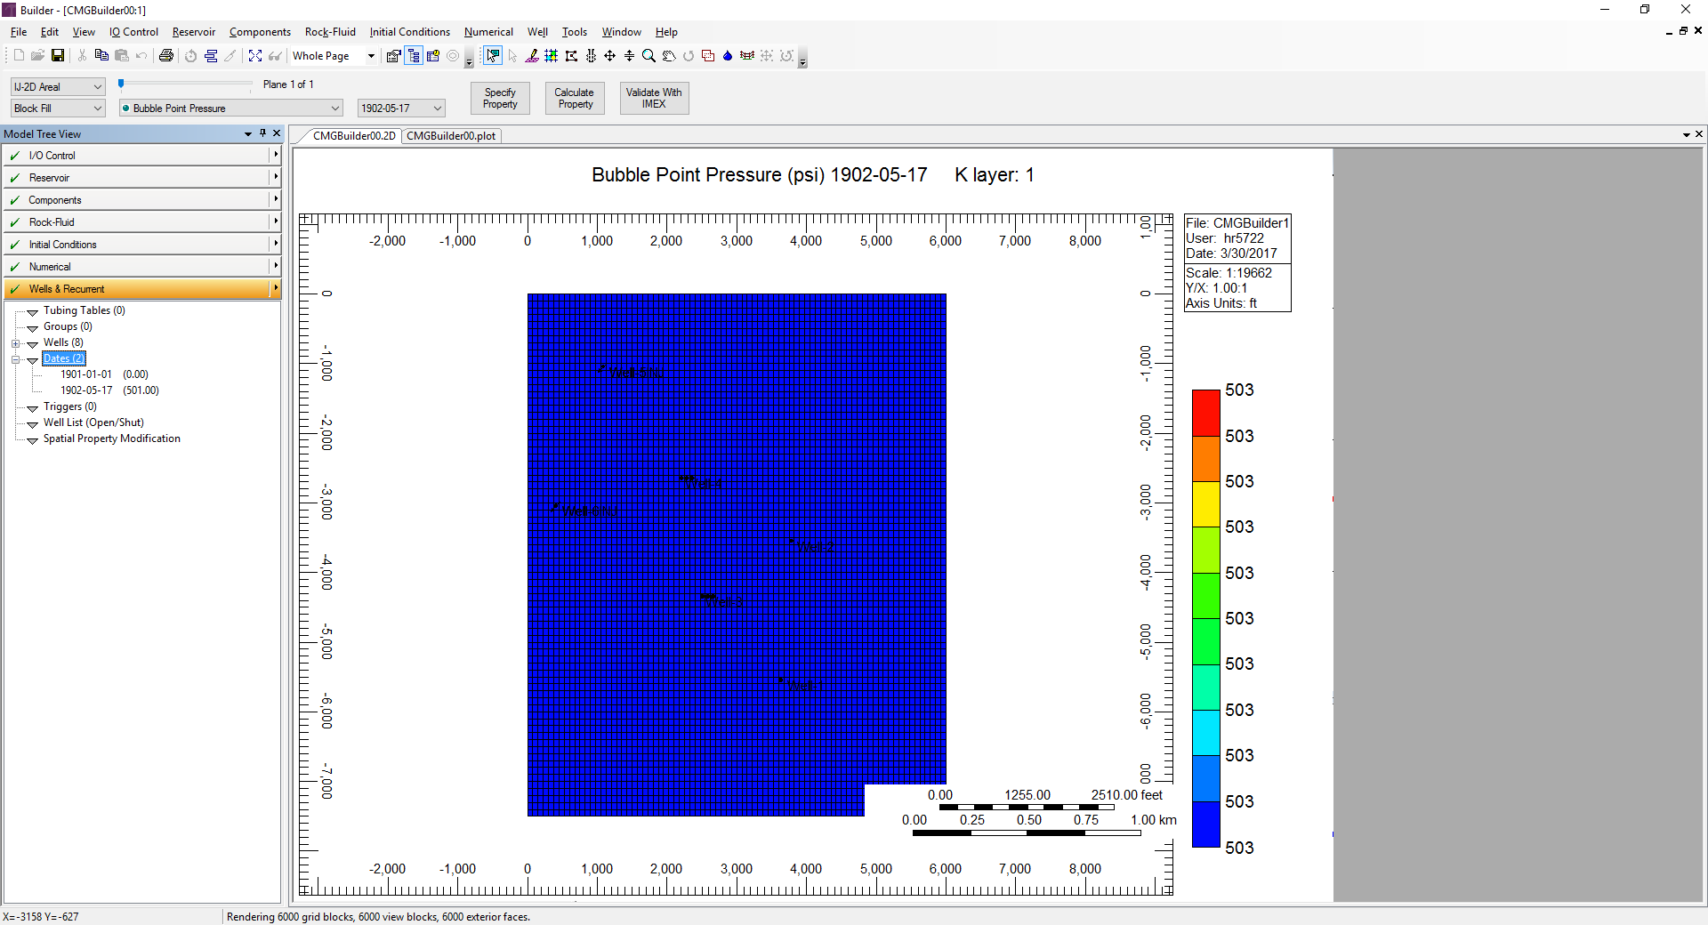

1. Click add a range of dates
2. Set “To” date to 1001 days since simulation start

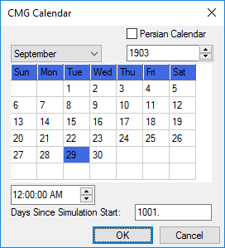

1. Click OK
2. Set Step to 1 day

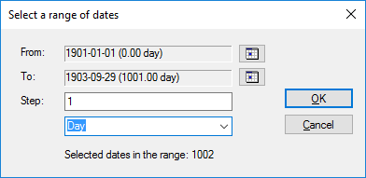

1. Click ok
2. Click close

**SAVE CMG FILE**

1. Click File🡪 Save 🡪 Select location and change name

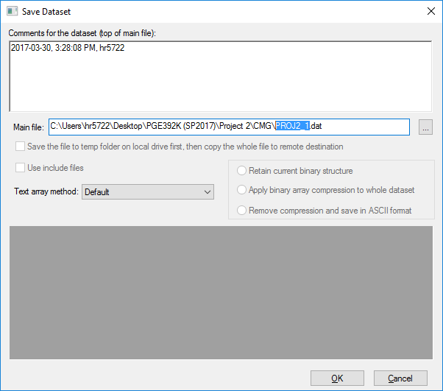

1. Press ok
2. Exit builder

**ADDING HETEROGENEITY**

We have heterogeneity in depth, porosity, permeability and will change these manually by using the text version of .dat file that we just created

1. Change AXES DIRECTION TO 1.0 1.0 1.0
2. Delete DTOP 6000*0
3. Write DTOP
4. In the line below copy and paste PJ1-DTop file (just absolute value of depth file -25 ft since depth given is to the center of the gridblock)
5. Delete PERMI CON 100
6. Write PERMI
7. In the line below copy and paste PJ1-Permeability file
8. Delete POR CON 0.2
9. Write POR
10. In the line below copy and paste PJ1-Porosity file
11. Find WELL ‘Well-3’
12. Replace K after GEOMETRY with I (this is done because this horizontal well is in the I direction unlike vertical wells which are in K direction)
13. Repeat step 13 for Well-4